TIME SERIES ANALYSIS AND FORECASTING

EX:4

AIM:TO IIMPLEMENT THE PROGRAM TO CHECK STATIONARY OF THE TIME SERIES DATA

PROCEDURE: Here’s a **shortened step-by-step procedure** for checking the stationarity of a time series (like birth rate data):

**Step 1: Visual Inspection**

* **Plot the Time Series**: Look for trends or seasonality. Stationary data should have constant mean and variance.
* **Rolling Statistics**: Plot the rolling mean and variance to check if they remain constant over time.

**Step 2: ADF Test (Augmented Dickey-Fuller)**

* **Null Hypothesis (H₀)**: The series is non-stationary.
* **Interpretation**:
  + **p-value < 0.05**: Reject H₀, the series is **stationary**.
  + **p-value > 0.05**: Fail to reject H₀, the series is **non-stationary**.

**Step 3: KPSS Test**

* **Null Hypothesis (H₀)**: The series is stationary.
* **Interpretation**:
  + **p-value < 0.05**: Reject H₀, the series is **non-stationary**.
  + **p-value > 0.05**: Fail to reject H₀, the series is **stationary**.

**Step 4: Differencing (if needed)**

* **First-order Differencing**: Subtract each value from the previous one.
* Recheck stationarity after differencing using the ADF and KPSS tests.

**Step 5: ACF/PACF Plots**

* Plot **ACF** and **PACF**:
  + **Stationary series**: Autocorrelations drop quickly.
  + **Non-stationary series**: Autocorrelations persist over many lags.

OUTPUT: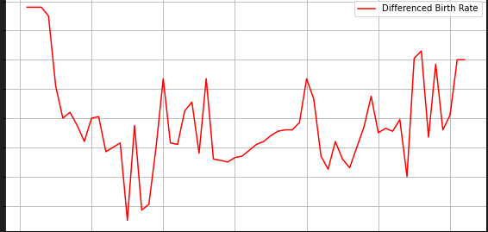

RESULT:THE PROGRAM HAS BEEN SUCESSFULLY IMPLEMENTED FOR CHECK STATIONARY OF TIME SERIES DATA